

|  |  |  |  |  |
| --- | --- | --- | --- | --- |
| 72 Central Campus Dr Salt Lake City, UT 84112 |  |  |  | fluorender@sci.utah.edu  www.fluorender.com |

FluoRender Tutorials

Version 2.23.1/December 2018

|  |  |
| --- | --- |
|  | **Many of the tutorials have corresponding demonstration videos published on YouTube.com. Tutorials with videos are identified with the YouTube logo: .**  **You may follow the links to watch these videos. Or, you can search the title of the video on YouTube.** |
|  | **Please make sure that you have the latest graphics driver installed on your computer before start using FluoRender. Your graphics card needs to support:**  **OpenGL 4.0**  **OpenCL 1.2**  **Look up your graphics card’s capability on Wikipedia.org**  **For AMD graphics processing units:**  [**https://en.wikipedia.org/wiki/List\_of\_AMD\_graphics\_processing\_units**](https://en.wikipedia.org/wiki/List_of_AMD_graphics_processing_units)  **For Intel graphics processing units:**  [**https://en.wikipedia.org/wiki/List\_of\_Intel\_graphics\_processing\_units**](https://en.wikipedia.org/wiki/List_of_Intel_graphics_processing_units)  **For Nvidia graphics processing units:**  [**https://en.wikipedia.org/wiki/List\_of\_Nvidia\_graphics\_processing\_units**](https://en.wikipedia.org/wiki/List_of_Nvidia_graphics_processing_units) |

Table of Contents

[List of Figures 3](#_Toc497394993)

[Tutorial 1 Downloading and Installing FluoRender 5](#_Toc497394994)

[Tutorial 2 Visualizing Multichannel Data 7](#_Toc497394995)

[Tutorial 3 Loading Different Volume Formats 15](#_Toc497394996)

[Tutorial 4 Visualizing a Time Sequence 20](#_Toc497394997)

[Tutorial 5 Visualizing Mesh Objects 24](#_Toc497394998)

[Tutorial 6 Screen Capture and Movie Export 26](#_Toc497394999)

[Tutorial 7 Measuring Position, Length, and Volume 31](#_Toc497395000)

[Tutorial 8 Channel Segmentation with Paint Brush 36](#_Toc497395001)

[Tutorial 9 Analyzing Components 40](#_Toc497395002)

[Tutorial 10 Fully Automatic Tracking of Components 44](#_Toc497395003)

[Tutorial 11 Manually Fixing Automatic Tracking Issues 50](#_Toc497395004)

[Tutorial 12 Fully Manual Tracking 55](#_Toc497395005)

[Tutorial 13 Image Processing with OpenCL Kernels 58](#_Toc497395006)

[Index 60](#_Toc497395007)

# List of Figures

[Figure 1‑1. FluoRender’s download page. 5](#_Toc497395008)

[Figure 1‑2. FluoRender’s source code download page. 6](#_Toc497395009)

[Figure 2‑1. Layered channel intermixing mode. 8](#_Toc497395010)

[Figure 2‑2. Depth channel intermixing mode. 9](#_Toc497395011)

[Figure 2‑3. Composite channel intermixing mode. 10](#_Toc497395012)

[Figure 2‑4. Increase depth attenuation value to darken deep structures. 10](#_Toc497395013)

[Figure 2‑5. Volume properties. 10](#_Toc497395014)

[Figure 2‑6. Color mapping modes 12](#_Toc497395015)

[Figure 2‑7. The output adjustment panel. 13](#_Toc497395016)

[Figure 2‑8. Clipping plane panel. 14](#_Toc497395017)

[Figure 3‑1. Open volume in the main toolbar. 16](#_Toc497395018)

[Figure 3‑2. Open dialog for Z-stack sequence. 16](#_Toc497395019)

[Figure 3‑3. Setting default colors for excitation wavelengths. 17](#_Toc497395020)

[Figure 3‑4. Open Olympus formats. 18](#_Toc497395021)

[Figure 3‑5. Open a Prairie XML file. 19](#_Toc497395022)

[Figure 4‑1. Open a TIFF-based time sequence. 21](#_Toc497395023)

[Figure 4‑2. Correct loading of a time sequence. 22](#_Toc497395024)

[Figure 4‑3. Controls for time sequence playback. 22](#_Toc497395025)

[Figure 4‑4. Settings for movie export. 23](#_Toc497395026)

[Figure 5‑1. An example of a mesh-based atlas built with FluoRender and other tools. 24](#_Toc497395027)

[Figure 5‑2. Mesh properties. 24](#_Toc497395028)

[Figure 5‑3. Mesh transparency quality settings. 25](#_Toc497395029)

[Figure 6‑1. Capture a single image of the rendering view port. 26](#_Toc497395030)

[Figure 6‑2. Enable cropping. 27](#_Toc497395031)

[Figure 6‑3. Rotation movie settings. 27](#_Toc497395032)

[Figure 6‑4. Advanced panel is for recording key frame animations. 28](#_Toc497395033)

[Figure 6‑5. Settings for an added key frame. 28](#_Toc497395034)

[Figure 6‑6. Common controls for movie playback and export. 29](#_Toc497395035)

[Figure 6‑7. Save movie dialog and its settings. 29](#_Toc497395036)

[Figure 7‑1. Real-time coordinate information of mouse cursor. 31](#_Toc497395037)

[Figure 7‑2. Measurement window. 32](#_Toc497395038)

[Figure 7‑3. Different ruler tools. 34](#_Toc497395039)

[Figure 7‑4. Track a cell using the ruler tool. 35](#_Toc497395040)

[Figure 8‑1. The “Analyze” window. 36](#_Toc497395041)

[Figure 8‑2. Segmentation with paint brush. 37](#_Toc497395042)

[Figure 8‑3. Edge detection strength 38](#_Toc497395043)

[Figure 8‑4. Select structures section by section. 39](#_Toc497395044)

[Figure 9‑1. The basic settings in the “Components” dialog. 40](#_Toc497395045)

[Figure 9‑2. The advanced settings in the “Components” dialog. 42](#_Toc497395046)

[Figure 9‑3. Components visualized in different colors. 43](#_Toc497395047)

[Figure 10‑1. Loading the sample 4D sequence into FluoRender 44](#_Toc497395048)

[Figure 10‑2. Enable a 4D script for generating components 45](#_Toc497395049)

[Figure 10‑3. FluoRender shows the components generated for each time point when you play back and execute the script. 46](#_Toc497395050)

[Figure 10‑4. Generating a track map. 47](#_Toc497395051)

[Figure 10‑5. Stepping through time. 48](#_Toc497395052)

[Figure 10‑6. Selecting components by ID. 48](#_Toc497395053)

[Figure 10‑7. Ghosts of a tracked cell. 49](#_Toc497395054)

[Figure 11‑1. The UniIDs tool generates a new sequence with consistent IDs through time. 50](#_Toc497395055)

[Figure 11‑2. The Linkage tab of the Components and Tracking window. 51](#_Toc497395056)

[Figure 11‑3. Exclusive Link. 51](#_Toc497395057)

[Figure 11‑4. Link IDs. 51](#_Toc497395058)

[Figure 11‑5. Isolate. 52](#_Toc497395059)

[Figure 11‑6. Unlink IDs. 52](#_Toc497395060)

[Figure 11‑7. The Modify tab of the Components and Tracking window. 52](#_Toc497395061)

[Figure 11‑8. Assign ID. 53](#_Toc497395062)

[Figure 11‑9. Add ID. 53](#_Toc497395063)

[Figure 11‑10. Combine IDs. 53](#_Toc497395064)

[Figure 11‑11. Divide an ID group. 54](#_Toc497395065)

[Figure 12‑1. Loading the sample 4D sequence into FluoRender 55](#_Toc497395066)

[Figure 12‑2. Enable a 4D script that allows tracking selected components. 56](#_Toc497395067)

[Figure 12‑3. Enable Auto Assign and Auto Link. 56](#_Toc497395068)

[Figure 13‑1. OpenCL kernel editor. 58](#_Toc497395069)

# Downloading and Installing FluoRender

FluoRender is a free and “open-source” software package developed by the Scientific Computing and Imaging (SCI) Institute at the University of Utah. To use FluoRender, you can download an installation package and install on your computer. Or, you can download the source code, and then build your own version.

1. Prepare your computer’s hardware and software environment. FluoRender demands fast graphics processing capability of GPUs. It is preferably run on the latest high-end hardware configurations with the latest graphics driver installed. Also make sure your system supports at least OpenGL 4.0 and OpenCL 1.2 for FluoRender from version 2.19 and later. Failure to comply with the system requirement may result from slow/limited functions to system crash.

2a. To download the executables, go to <https://github.com/SCIInstitute/fluorender/releases>. You may need to scroll down to the section of the webpage that contains links to the downloadable files. Previous releases of FluoRender are also available down below.



Figure 1‑1. FluoRender’s download page.

2b. The latest version is listed foremost. A download list (box in Figure 1‑1) contains links to executables, documentations, sample data, and source code.

2c. Make sure the OS in a file name matches your operating system. For example, for FluoRender version 2.20 on Mac OS X, the setup file is FluoRender\_2.20\_osx64.pkg. You can also download a user’s guide as well as this documentation (tutorials) from the list of files.

2d. After downloading finishes, locate the setup file within a file browser of your operating system. Double-click the setup file to initiate the installation process. Depending on the operating system that you are using, the installation process can vary. However, you should be able to follow the steps according to screen prompt. Refer to the user’s guide for more details.

2e. Locate the installed executable or its shortcut on your operating system and launch FluoRender.

3a. To download the source code, go to <https://github.com/SCIInstitute/fluorender>.



Figure 1‑2. FluoRender’s source code download page.

3b. Third-party libraries are needed in order to build FluoRender, including wxWidgets (<https://www.wxwidgets.org/>) and Boost (<http://www.boost.org/>). Make sure that you download these libraries as well.

3c. Additionally, you will need CMake (<http://www.cmake.org/>) and VisualStudio on Windows, or XCode on Mac OS X.

3d. Build the third party libraries first. Then, generate VisualStudio or XCode projects using CMake. Refer to the instructions on FluoRender’s github webpage for more details.

3e. Build FluoRender using VisualStudio on Windows, or XCode on Mac OS X.

# Visualizing Multichannel Data

|  |  |
| --- | --- |
|  | **On YouTube:**  [**https://youtu.be/pUDPZiFGk9E**](https://youtu.be/pUDPZiFGk9E)  **Or search:**  **FluoRender Tutorials Visualizing Multichannel Data** |

FluoRender allows visualization of multiple channels with unprecedented flexibility. Follow these steps to prepare, load, and visualize multichannel volumes. You may need to first read the user’s guide to get familiar with the terminology used in FluoRender’s user interface elements. The user’s guide can be either accessed within FluoRender, or downloaded here: <https://www.sci.utah.edu/download/fluorender.html>.

1. Prepare data. For best visualization results, make sure all channels have a coherent spatial resolution. TIFF or original microscopy formats are the preferred storage formats. If TIFF is used, TIFF Z-stacks, instead of individual sections, are preferred. Make sure that the files are properly named for easy organization. It is also recommended that all files are saved in one directory for easy loading. A three-channel sample data set can be downloaded from FluoRender’s website: <http://www.sci.utah.edu/software/fluorender.html>.

2. To load multichannel data, click “Open Volume”  in the main toolbar. In the file browser dialog, choose all files, and then click “Open”. All selected files are loaded and visualized in FluoRender. If loading takes a long time, a progress dialog will show.

|  |  |
| --- | --- |
|  | If channels to be visualized simultaneously are large in spatial resolution or number of channels, enable “large data streaming” for improved interactivity. To enable “large data streaming”, first click “Settings”  in the main toolbar. In the setting dialog, choose the “Performance” tab. Then, under the “Large Data Streaming” section, check “Enable streaming for large datasets”. You may also adjust the detailed settings to match your system’s hardware configuration. |

3. All loaded files are visualized with default settings. You can rotate, zoom, or pan the render view using mouse interactions. To rotate the view, click anywhere in the render view with the left mouse button, hold down the left mouse button, and then drag the mouse to the intended direction. To zoom the view, click anywhere in the render view with the right mouse button, hold down the button, and then drag the mouse. To pan the view, click anywhere in the render view with the middle mouse button, hold down the middle button, and then drag the mouse to the intended direction.

4. FluoRender provides three channel intermixing modes to best visualize features from different channels in an interactive setting. To switch among the channel intermixing modes, use buttons in the top toolbar of the render view.

**Layered** . Channels are rendered individually and then layered one on top of another. Top channels in the workspace are also rendered on top. Changing the order of channels in the workspace will affect the visualization result. Layered mode is good for un-occluded visualization of features from top channels.



Figure 2‑1. Layered channel intermixing mode.

**Depth** . Channels are intermixed with correct spatial occlusion. Depth mode is good for inspecting spatial relationships between channels.



Figure 2‑2. Depth channel intermixing mode.

**Composite** . Channels are rendered individually and then their colors are summed up. Composite mode is good for visualizing otherwise occluded features of colocalized structures .



Figure 2‑3. Composite channel intermixing mode.

5. Use “Depth Attenuation” to darken structures that are farther from the viewer in 3D space, so that spatial relationship may become more obvious. Turn on depth attenuation by clicking its icon . Adjust the slider below to change its intensity.



Figure 2‑4. Increase depth attenuation value to darken deep structures.

6. You can select a visualized channel from both the render view and the workspace panel. To directly select a channel from the render view, click where a channel has the strongest signal intensity. The selected channel is highlighted in the “Workspace” panel, its properties loaded into the “Property” panel. To select a channel from the “Workspace” panel, click the name of a channel to highlight it.

7. You can reorganize visualized channels in the “Workspace” panel. To reorganize the order of channels, click and drag the name of a channel to reorder it. To rename a channel, first select it in the “Workspace” panel. A corresponding file name will also be highlighted in the “Datasets” panel. Click “Rename” **** in its toolbar. It then allows you to type a new name for the selected channel.

8. When a channel is selected and visible, its adjustable properties are shown in the “Property” panel. You can adjust the following parameters. You should see the results of each parameter immediately when you change it.



Figure 2‑5. Volume properties.

**Gamma**. It adjusts the nonlinear intensity and transparency mapping. You can decrease it to remove noise signals.

**Saturation**. It sets a threshold value that maps to the maximum output, or “saturated” output. If a channel has low input intensity signals, decrease this parameter to enhance low intensity signals.

**Luminance**. It is linked to the luminance of a channel’s color. Decrease this value if a channel’s input is too bright.

**Alpha**. It is a multiplier to a channel’s transparency mapping. Decrease this parameter to make a channel more transparent.

**Extract boundary**. It is a threshold value for the gradient magnitude of a channel. Increase this parameter to extract salient boundary structures.

**Threshold (low and high)**. Only voxels with intensity values between low and high threshold values are visualized. Use this setting to exclude low intensity noise.

**Primary color**. It is the base color of a selected volume channel. Use different colors to distinguish multiple channels.

**Secondary color.** It is the color to highlight selected structures within a volume. By default, the highlight color is calculated as the inverse of the primary color and changes with it. Once you choose a secondary color, it is fixed to your choice.

**Color map**. You can enable a color map to assign different colors to low and high intensity values of a channel. The mapping of color range can be adjusted using its low and high settings.

Additionally, you can choose among several color maps.

|  |  |
| --- | --- |
| **Rainbow** |  |
| **Reverse rainbow** |  |
| **Hot** |  |
| **Cool** | E:\OneDrive\FluoRender\cm04_cool.png |
| **Diverging** | E:\OneDrive\FluoRender\cm05_div.png |

You can also choose how the color map is applied. In addition to mapping to intensity values, colors can be mapped to X, Y, and Z coordinates as well.



Figure 2‑6. Color mapping modes

**Invert** . It inverts low and high intensity signals.

**Shading**. You can enable shading effect for a channel.

**Light**. Use this parameter to adjust the ratio between highlight and shade.

**Shadow**. You can apply shadow effect for a channel.

**MIP**. It turns on/off MIP, or maximum intensity projection, mode. Use this mode to visualize concentrations of high intensity signals.

**Sample rate**. It determines the number of slices for rendering one voxel. A higher value improves the rendering quality.

**Interpolation** . It decides the interpolation methods for volume rendering. If it is enabled, trilinear interpolation is used; otherwise nearest neighbor lookup is used.

**Smoothing** . You can enable smoothing if high frequency artifacts are observed at high zoom levels.

**Spacing**. If the sample spacing is not read correctly from the metadata, or the default values are incorrect, change the spacing values to correct the voxel size in X, Y, and Z directions.

9. You can save the settings for a satisfied visualization result, and apply to similar data sets. To save default settings, click “Save settings” . To recall default settings, click “Reset” .

10. In addition to properties of each channel, you can adjust the output of intermixed result of multiple channels. These settings are in the “Output Adjustment” panel on the left side of the render view. Three parameters are available for making adjustment to each output color channel.



Figure 2‑7. The output adjustment panel.

**Gamma**. It uses a gamma curve to remap the output color intensities in a nonlinear fashion.

**Luminance**. It is a multiplier to output color intensities.

**Equalization**. Depending on current selection in the “Workspace” panel, the effect of this parameter can vary. When a channel or its group is selected, it enhances details in low output color intensities; when a render view is selected, it suppresses high output intensity signals, especially those out of the range of display hardware. Settings for these two selection types can be used together.

11. When deep 3D structures are occluded, use clipping planes to reveal them. When a channel is selected in the “Workspace” panel, its clipping plane settings are shown in the “Clipping plane” panel. You can translate and rotate clipping planes. To translate a clipping plane, use one of the six sliders. The clipping plane currently being translated is shown in the render view. To rotate all six clipping planes, use one of the three sliders for rotation around X, Y, or Z axis.



Figure 2‑8. Clipping plane panel.

# Loading Different Volume Formats

|  |  |
| --- | --- |
|  | **On YouTube:**  [**https://youtu.be/YjPaqZVvV-w**](https://youtu.be/YjPaqZVvV-w)  **Or search:**  **FluoRender Tutorials Handling Different Data Formats** |

FluoRender supports a series of volume formats. Loading one specific format can be different from another.

1a. Loading a Z-stack sequence. A Z-stack sequence is a volume saved as a series of 2D image sections. Each 2D image section is saved as a TIFF file. The names of the TIFF files need to follow a naming convention. First, all file names are composed of a common character string and a digit string. The common character string is the same through all file names and is used to identify the stack; the digit string is for identification of the Z image section order. Second, the digit string can appear at any place within the common character string. However, if there are more than one separated digit string within the file names, only the last one is used as the string to order the Z sections. For example, a legitimate Z-stack sequence looks like:

e145scx32neuro007z01RGB.tif

e145scx32neuro007z02RGB.tif

…

e145scx32neuro007z34RGB.tif

Notice that although in one file name there are more than one separated digital string, only the last one (after letter “z” and before “RGB”) is used to identify the order of Z sections.

Additionally, each TIFF file contains only one image section, which could have multiple channels.

Third, all files need to be in the same file folder.

1b.Click “Open Volume”  in the main toolbar of FluoRender.



Figure 3‑1. Open volume in the main toolbar.

1c. In the file browser dialog, browse to the folder containing all section files. Select just one file of the Z-stack sequence. Check “Read a sequence as Z slices” in the “Additional options”. Then, click “Open”.



Figure 3‑2. Open dialog for Z-stack sequence.

2a. Loading Olympus microscopy formats. OIB and OIF files are supported. An OIB is a binary file that contains all necessary data and information. However, an OIF is an index file that should be accompanied by a file folder of the identical name plus “.files”. Since the folder contains the actual data, you need to copy both in order to have it opened correctly.

2b. FluoRender can read the metadata from Olympus formats and assign colors based on excitation wavelengths. To set the default colors, click “Settings”  in the main toolbar. Go to the fourth panel of the setting dialog “File format”. Choose the default colors for each wavelength range. Then, click “Done” to save the settings and close the setting dialog.



Figure 3‑3. Setting default colors for excitation wavelengths.

2c. To load an Olympus file, click “Open Volume”  in the main toolbar. In the file browser dialog, browse to the folder containing the Olympus file. Choose \*.oif or \*.oib files. Make sure “Read a sequence as Z slices” is unchecked. Then, click “Open” to load selected files.



Figure 3‑4. Open Olympus formats.

3. Loading Zeiss format LSM. An LSM file can be opened similarly as both a multipage TIFF (Z-stack in a single file) and an OIB file.

4a. Loading Prairie XML format. A Prairie XML file is similar to an OIF file, which is an index to a series of TIFF sections. However, the XML file should be saved in the same folder as the TIFFs. You need to copy the entire folder generated by PrairieView in order to open the scan correctly. Also notice that you are not supposed to rename anything in order for FluoRender to correctly locate the TIFFs.

4b. To load a Prairie XML file, click “Open Volume”  in the main toolbar. In the file browser dialog, find and select just the XML file.



Figure 3‑5. Open a Prairie XML file.

# Visualizing a Time Sequence

|  |  |
| --- | --- |
|  | **On YouTube:**  [**https://youtu.be/YjPaqZVvV-w?t=36s**](https://youtu.be/YjPaqZVvV-w?t=36s)  **Start at 0:36, Part II Time Sequence**  **Or search:**  **FluoRender Tutorials Handling Different Data Formats** |

FluoRender supports visualization a time sequence. A time sequence is a series of scans over time, a volume at each time point. Most of the microscopy formats support time sequence storage. It is recommended that you keep the original formats if supported by FluoRender for best performance. In addition, a TIFF sequence can be loaded as a time sequence on condition that their file names follow a certain naming convention.

1a. A time sequence based on the TIFF format need to be named correctly. First, the name of a file in the sequence is composed of three parts: a common character string, a time sequence identifier, and a digit string. The common character string and the time sequence identifier have to stay the same through the entire sequence. The time sequence identifier can only appear once in one file name. The digit string is used to order time points. Second, the digit string has to follow the time sequence identifier without separation. The group of these two parts can appear at any place within the common character string. A legitimate time sequence based on TIFF format looks like:

e145scx32neuro007\_T01RGB.tif

e145scx32neuro007\_T02RGB.tif

…

e145scx32neuro007\_T34RGB.tif

It is recommended that each TIFF file stores the entire volume at one time point.

Third, all files of the sequence need to be saved in the same folder.

1b. To load the TIFF-based time sequence, click “Open Volume”  in the main toolbar. In the file browser dialog, browse to the folder containing the time sequence. Select just one file of one time point. Make sure the time sequence identifier in the “Additional options” matches that of the sequence. Then, click “Open” to load the sequence.



Figure 4‑1. Open a TIFF-based time sequence.

1c. If a time sequence is saved in one of the supported microscopy formats, you can load it normally. The first time point is visualized.

2. Regardless the format, if a time sequence is correctly loaded, in the “Record/Export” panel, “Time sequence” is automatically checked. In addition, the range of time points in the sequence is also shown as “Start Time” and “End Time”.

|  |  |
| --- | --- |
|  | You can still check the “time sequence” option even if a time sequence is not loaded correctly. However, this becomes the “batch” mode instead of time sequence playback. The batch mode considers all files within a folder as a batch, it uses the alphabetical order of the file names to play back the sequence. If this happens to a time sequence, first make sure you name the sequence correctly and then reload it. Forcing an incorrectly named time sequence into batch mode may result our-of-order files. |



Figure 4‑2. Correct loading of a time sequence.

3. You can play back the time sequence by clicking the “Play”  button. Clicking it twice will stop the playback. Once the playback stops, you can rewind it to the beginning of the sequence by clicking “Rewind” . To step the time sequence one time point at a time, click  to go forward, and  to go backward. Additionally, you can type in the value for the “Current Time” or use the time slider.



Figure 4‑3. Controls for time sequence playback.

4. The playback speed of a time sequence is determined by the FPS (Frames per Second) value, movie length, and time point range. For example, 30 FPS means the output is rendered at a speed of 30 frames per second. When the movie length is 8 seconds, there will be 30x8=240 frames rendered. However, there are only 209+1=210 time points, which means some output frames will have the same time point in order to fill the total length of 8 seconds. You can adjust any of these parameters to fine-tune the playback speed of a time sequence. For example, you can increase the movie length for a slower playback speed.

5. You can save the rendering of a time sequence playback as a series of 2D images, or a QuickTime movie. To do so, rewind the time sequence to its beginning, and then click “Save” ****. In the “Save Movie” dialog, browse to a folder for saving the movie file. In the “save as type” dropdown list, you can choose to save the movie as either a QuickTime movie file (\*.mov), or a sequence of TIFF files (\*.tif). Depending on the choice of file type, there are two different sets of options available. For a TIFF sequence, you can choose to compress with the Lempel-Ziv-Welch algorithm (LZW). To use LZW compression, check “Lempel-Ziv-Welch Compression”. For a QuickTime movie file, you can set its bit rate. To set the bit rate, type in a value in the range of 0-20. After you finish typing the bit rate value, an estimation of the QuickTime movie file size is calculated and updated in the “Estimation size” text box. After all these settings, click “Save” to render the sequence and output the movie.



Figure 4‑4. Settings for movie export.

# Visualizing Mesh Objects

Mesh objects can be visualized along with volume channels. It is possible to make detailed anatomical atlases comprising of both volumes and mesh objects.

1. Prepare data. Only Wavefront OBJ format is currently supported. The OBJ format is a text file containing geometry information. In addition to the basic feature set of the OBJ format, FluoRender is able to support materials and textures. Textures have to be saved in TGA format. An alpha channel can be saved with the TGA format to modulate transparency. FluoRender can be used to generate mesh objects from the selected structures of a volume channel. However, we recommend using mesh editing software packages for well-defined results. Here is an on-line tutorial on using Maya to build muscles from volume data: <http://www.cs.utah.edu/~wanyong/maya/>.



Figure 5‑1. An example of a mesh-based atlas built with FluoRender and other tools.

2. To load mesh objects, click “Open Mesh”  in the main toolbar. In the file browser dialog, choose one or multiple mesh files and load them. The loaded mesh files should be visualized in the render view.

3. The same render view interactions for volume channels apply similarly to visualizing mesh objects. You can rotate, zoom, and pan the view. Additionally, you can click and select a mesh object directly from the render view.

4. The selected mesh object’s name is highlighted in the “Workspace” panel. Its look can be further customized through the settings in the “Property” panel.



Figure 5‑2. Mesh properties.

**Diffuse color**. The base color of the mesh object.

**Specular color**. The color of the mesh object’s highlight.

**Shininess**. The size of the mesh object’s highlight.

**Transparency**. The overall transparency of the mesh object. Lower is more transparent.

**Shadow**. It applies a shadow effect on the mesh object. Its strength can be adjusted with the slider.

5. If any number of mesh objects are semi-transparent either by setting or texture, depth peeling is used to remove artifacts from random ordering. To adjust the quality of semi-transparent mesh objects, adjust the depth peeling layers in the “Settings” dialog. To open the “Settings” dialog, click “Settings”  in the main toolbar. The depth peeling settings are under the second tab “Rendering”. Increase the number of peeling layers for better transparency quality.



Figure 5‑3. Mesh transparency quality settings.

# Screen Capture and Movie Export

|  |  |
| --- | --- |
|  | **On YouTube:**  [**https://youtu.be/R43WkfValF0**](https://youtu.be/R43WkfValF0)  **Or search:**  **FluoRender Tutorials Capturing Render View and Movie Export** |

You can capture the rendering result in a render view port and save it as an image file. You can also export a movie for a series of renderings, including rotation, zooming, clipping plane movements, and time sequence.

1. To capture the rendering result in a render view port, click the button Capture. It prompts you to save the result as a TIF file.



Figure 6‑1. Capture a single image of the rendering view port.

2. You can enable automatic cropping of the view port. Go to the “Record/Export” panel, and then click “Cropping” tab. Check “Cropping” to enable it. When enabled, the default cropping region is calculated to just include the currently selected volume channel. The cropped region is shown as a yellow-bordered box.



Figure 6‑2. Enable cropping.

3. You can also adjust the size and position of the cropping region with the numeric inputs in the cropping tab.

4. When view is changed, you can reset the cropping region by clicking the reset button . It recalculates the cropping region to just include the currently selected volume channel.

5. To make simple rotation movies, click the “basic” tab of the “Record/Export” panel. Make sure only the “Rotation” option is checked. Then, choose an axis for the rotation. Notice that the Y axis is pointed up by default. So, rotation around the Y axis looks like a common “turntable” animation. Type in the number of degrees of the rotation. Notice that you can type in a negative number to make a rotation movie of the opposite direction.



Figure 6‑3. Rotation movie settings.

6. More complex movies can be recorded in the “Advanced” panel of the “Record/Export” panel. It is a recorder of key frames. For each key frame, you can change the viewing angle, channel visibility, and clipping planes. Then, you specify the number of frames between two consecutive key frames. These frames, called in-betweens, are generated by interpolating changing parameters.



Figure 6‑4. Advanced panel is for recording key frame animations.

7 To record a key frame animation, first find the initial settings for the view port. Click “Add” to add a key frame into the key frame list above. Notice that you can set the inbetween number and the interpolation method beforehand, using the inputs to the left of the “Add” button. A recorded key frame is listed in the key frame list. You can still modify the number of in-betweens and interpolation method after adding a key frame. Notice that the inbetween number denotes those before the currently selected key frame. So the number for the first key frame will always be 0. Additionally, you can type a descriptive text in the description box, to help you organize the key frames.



Figure 6‑5. Settings for an added key frame.

8. You can change the view port by rotating, panning, and zooming, or change the clipping plane settings. Then, record another key frame by clicking the “Add” button again. You can repeat this process until a complex animation is completely recorded. You can view the result of each key frame by double-clicking it in the key frame list.

|  |  |
| --- | --- |
|  | Rotation of more than 180 degrees may confuse the interpolation, since it calculates the shortest distance between two key frames. To make sure rotations are recorded correctly, use rotation angles less than 180. |

9. To play back the animation, you need the common controls in the “Record/Export” panel. First, make sure the intended render view is selected in the dropdown list after “Capture:” when multiple render views are used. Next, specify a play back sped by typing the FPS number. Notice that although you can type in a very large FPS number, it may not be able to achieve the speed. In this situation, it will render as fast as possible during play back. The FPS information is saved within a movie file if the QuickTime format is chosen. Then, click the play back button to preview the animation. Click it again to stop playing back. You can also rewind the animation or advance to any time of the animation using the slider and time input box.



Figure 6‑6. Common controls for movie playback and export.

10. If the preview shows a satisfactory result, you may want to save the result. The result can be saved as either a sequence of TIF images, which need an external tool to get assembled into final movie formats, or a single movie file in the QuickTime format. To save the movie result, click the “Save…” button. It brings the file save dialog. You can choose the format here. Once a format is decided, more detailed settings are available in the additional options region. For a TIF sequence, you can choose to save the images compressed. For a movie file, you can choose the bit rate of the movie. Higher bit rate means higher image quality, but also larger file size. The estimated file size is updated according to the setting of bit rate. Please use the estimated size only as a reference.



Figure 6‑7. Save movie dialog and its settings.

|  |  |
| --- | --- |
|  | Movie files are compressed in a way that many frames are processed together. In order for the movie coder to generate a correct result, a certain minimum number of frames are required. Make sure you movie length is long enough for successful output. |

# Measuring Position, Length, and Volume

|  |  |
| --- | --- |
|  | **On YouTube:**  [**https://youtu.be/WruONla-R3M**](https://youtu.be/WruONla-R3M)  **Or search:**  **FluoRender Tutorials Making Measurements** |

When volume channels are visualized with FluoRender, you can acquire several quantified measurements using interactive tools.

1. Prepare data. If your data set is in one of the supported microscopy formats, it is likely that the size information is automatically retrieved from the metadata. You can turn on the scale bar in render view to make sure the size of a loaded data set is correct. To turn on the scale bar, click “Scale bar” **** in the top toolbar of the render view panel. Click it twice to enable the text for scale bar length and unit. If your data set is in an exchange format, such as TIFF, and does not contain size information, you can manually set the sample spacing, or voxel size, after loading. To set the sample spacing, click the name of a volume channel in the “Workspace” panel to load its properties into the “Property” panel. Then, set the spacing of X, Y, and Z to correct numbers. The subsequent measurement operations use the spacing information to calculate physical size.

2. To get real-time information on the position under the mouse cursor, turn on “Information”  in the top toolbar of the render view panel. When you move the mouse cursor within the render view, the head-up information shows current cursor position.



Figure 7‑1. Real-time coordinate information of mouse cursor.

3. More precise measurement can be made with tools in the “Measurement” window. To open the “Measurement” window, click the downward arrowhead on the right side of the analysis tool button in the main tool bar. In the dropdown menu, select “Measurement…”.



Figure 7‑2. Measurement window.

4. To get the coordinates of a point location, use the “Locator” tool. Click “Locator” **** in the toolbar of the “Measurement” window, and then click on a structure of a volume channel to place one locator. The position information is displayed in the list below. You can rotate the view to see that the locator is placed in 3D space. If the “Locator” button is kept pressed, you can create as many locators as you want.

5. The depth of a locator is automatically determined based on the underlying data. There are three options for fine-tuning the calculation of depth.

**View plane**. This option calculates the depth as a fixed value on a plane perpendicular to viewing direction. Use this option if there is no salient structures and you want to adjust the locator’s position manually.

**Maximum intensity**. This option calculates the depth at a voxel having the maximum intensity value along the viewing direction. If multiple voxels all have the maximum value, the closest is chosen. Use this option if you want to place the locator at the center of a structure, which has high intensity values inside.

**Accumulated intensity**. This option calculates the depth at a voxel that the accumulated transparency of the voxels in front of it becomes opaque. Use this option if you want to place the locator on the structural surface.

Furthermore, you can choose whether the depth is calculated from the original intensity values or mapped values after the volume properties are applied. Check **Use volume property** to use the mapped values after the application of volume properties. It is usually more accurate for depth calculations because the intensity value matches that of the visualization result. However, the depth calculation speed may be slower than when **Use volume property** is unchecked.

6. To manually change the position of a locator, click “Edit”  in the toolbar of the “Measurement” window. You can click and drag a locator within the render view. The settings that influence the depth calculation are still in effect when moving a locator.

7. To measure the volume of a certain structure, hold down the “Shift” key on keyboard in locator mode. This turns the locator tool into a brush tool. You can paint on a structure to select it. When you release the left mouse button, a locator is placed at the centroid of the selected structure. The volume of the selected structure is also calculated and shown in the list below. Settings for paint brush tools also apply to the paint brush in locator mode.

8. To measure the distance between two points, use the 2-point ruler tool. Click “2pt ruler” **** in the toolbar of the “Measurement” window, and then click twice in the render view for its starting and ending points. All settings for the locator tool apply similarly to the 2-point ruler tool. The length between the two points are shown in the list below. You can also modify the position of each ruler point using the “Edit” tool.

9. To measure the distance along a path of multiple points, use the 2+-point ruler tool. Click “2+pt ruler” **** in the toolbar of the “Measurement” window, and then click as many times as you want along a path. Right-click to end the path. The length along the path is shown in the list below. All settings for the locator tool apply similarly and you can edit the position of each ruler point using the “Edit” tool.

10. To automatically create a two-point ruler tool so that the line between the two end points goes through the selected volume from the viewing direction (like a drill), use the Probe tool. Click “Probe”  in the toolbar of the “Measurement” window, and then click on the volume where you want to “drill”. You can combine this tool with the paint brush tool by holding down the “Shift” key on the keyboard. When you click, it selects a cylindrical region along the “drilled” direction. The intensity profile within the region can be analyzed with the “Profile” tool.

11. Use the “Profile” tool to calculate an intensity profile along a ruler, or within a selected region generated by the “Probe” tool. To use the “Profile” tool, you need to first create a ruler, or use the Probe tool to generate a cylindrical selection. Then, select the ruler you want to profile in the list. Finally click the “Profile”  button in the toolbar of the “Measurement” window. An intensity profile along the ruler or within the selected region generated by the Probe tool is then calculated. To see the result from intensity profiling, you can export the calculated information by clicking the “Export”  button in the tool bar. The exported file is in text format. You can open it with a text editor, or preferably with a spreadsheet editor. You can then plot the result with the spreadsheet editor.

12. You can change the text and color of a selected measurement tool, so that a locator or ruler can be doubled as an annotation tool. Click and select a measurement tool from the list. A text box and a color swatch button will show at the selected position. Then, you can type in the text for the measurement tool, or choose a color. The changes to the measurement tool is immediately applied in the render view port.



Figure 7‑3. Different ruler tools.

13. Although the 2+-point ruler tool is not originally designed for tracking the movement of a structure, you can use it as a tracking tool. To use it as a tracking tool, make sure that the option “Transient” is unchecked. When this option is checked and a time sequence data set is loaded, a ruler tool can only exist in one particular time point, hence “transient”. When this option is off, you can create a 2+-point ruler for different time points. To use this feature, go to the first time point, click 2+-point ruler tool, hold down “Shift”, and paint on the structure to create the first point of the tracking. Then, advance to the next point, use the tool similarly to create the second point of the tracking. Continue this process until all time points are covered. The resulting path is the tracking of the structure.



Figure 7‑4. Track a cell using the ruler tool.

14. You can export the tracking result to a text file. To export the result, click “Export” **** in the toolbar of the “Measurement” window. Then, choose a path and file name to save. The saved file is compatible with most spreadsheet editors including Microsoft Excel. You can import the result into a spreadsheet editor for further analysis.

# Channel Segmentation with Paint Brush

|  |  |
| --- | --- |
|  | **On YouTube:**  [**https://youtu.be/qngb\_IZDHXE**](https://youtu.be/qngb_IZDHXE)  **Or search:**  **FluoRender Tutorials Selecting and Extracting Structures** |

FluoRender allows selecting and extracting 3D structures from volume channels. Users can directly paint on visualizations in render view and select desired structures.

1. Prepare data. Many segmentation functions are based on visualization results. Make sure that you have followed the previous tutorials to generate a satisfactory visualization. Although the paint brush tools can be used with bricks in data streaming mode, it is recommended that you turn off data streaming if your graphics card has sufficient memory. Changes to data streaming mode have to be made before data loading. To turn off data streaming, go to the “Performance” panel in the “Settings” dialog, and uncheck “Enable streaming for large datasets”.

2. Tools and settings for the paint brush can be accessed from the “Paint Brush” dialog. To open the “Paint Brush” dialog”, click “Paint Brush”  in the main toolbar. If the button is not currently showing, use the drop-down list on Windows, or the main menu, under Tools, on OS X.



Figure 8‑1. The “Analyze” window.

3. To initiate a selection, click the “select” button **** in the toolbar of the “Paint Brush” dialog. When you move the mouse cursor into a render view, the regions that a selection brush stroke can be applied are represented by circles. You can hold down the left mouse button and drag to apply a selection brush stroke. Three dimensional structures under the stroke region can be selected.



Figure 8‑2. Segmentation with paint brush.

4. There are several settings that further control the selection brush’s behavior, which you can adjust before applying strokes.

**Threshold.** It sets a seeding value to be applied to the center stroke region. Voxels with intensity values greater than the threshold are selected as seeds. Lower this value if you want to select more low intensity signals.

**Growth.** It determines the number of iterations for a diffusion calculation within the outer stroke region. Strong means more iterations, which allows selection to grow to a larger size.

**Center size.** It controls the size of the inner circle of a brush stroke. Lower the value to make selections on fine structures.

**Grow size.** It controls the size of the outer circle of a brush stroke. The size can be controlled by the mouse wheel. It can be turned off by unchecking the check box to the left of the slider. When it is turned off, no diffusion is calculated. The center size is in turn controlled by the mouse wheel.

5. After an initial selection using the selection brush, you can either append new regions to the existing selections, or unselect them. To append regions that are unconnected to the existing selections, use the selection brush again. To append regions that are connected to the existing selections, use the diffuse brush. Click the “Diffuse” button **** in the toolbar to choose the diffuse brush. The diffuse brush has only the outer circle for diffusion calculation. To select disregarding the underlying structures, use the solid brush . To unselect the existing selections, use the unselect brush. Click the “Unselect” button **** in the toolbar to choose the unselect brush.

6. You can apply brush strokes from different angles to achieve the best segmentation result. Use the following keyboard shortcuts to quickly switch between paint brush tools and normal render view interactions: holding down the “Shift” key for the selection brush; holding down the “Z” key for the diffuse brush; holding down the “X” key for the unselect brush.

7. You can let FluoRender estimate an initial threshold value by checking “Auto Thresh”. When this option is checked, you do not need to set a threshold value before applying a selection brush stroke. You can paint directly and FluoRender will calculate a threshold value for you. The calculation of the threshold value is based on the intensity distribution in the region covered by the stroke.

8. You can let the diffusion calculation stop at salient structural boundaries by checking “Edge Detect”. For example, check this option when you want to select just one cell from a group of cells that are in close proximity to each other. When the edge detection is enabled, you can adjust how strong the edge detection is performed by setting a value for “Edge STR”. Figure 8‑3 compares the different selected results from a series of edge detection strength settings. When the edge detection strength is set to 0, it is equivalent to disabling edge detection. Adjacent structures have been selected. When the edge detection strength is increased, fewer neighbors can be selected until a satisfactory result at edge strength = 0.6. When the edge detection strength is further increased, we start losing the exterior of the structure.



Figure 8‑3. Edge detection strength

9. You can let FluoRender automatically select only un-occluded structures by checking “Visibly Only”. When this option is checked, all seeding voxels are filtered to see if they are occluded by signal accumulation. Occluded seeds are discarded. You can check this option, for example, when you want to select just one cell from a group of cells that are occluding each other.

10. The selected part of a volume channel can be either extracted or removed from the original data, creating a new channel. To create a new channel by extracting the selected part, click “Extract” **** in the toolbar. To create a new channel by removing the selected part, click “Erase” **** in the toolbar.

11. Brush tools can be used in conjunction with clipping planes. You can set clipping planes to restrict the rendering of a channel to a sub-region. When you apply a brush stroke, selection can be only made within the visible region. A good example is that you can clip a volume to a single image section, and then select structures section by section, allowing classical 3D segmentation operations found in many other tools. More flexibility can be achieved as you may include any number of image sections between two facing clipping planes.



Figure 8‑4. Select structures section by section.

# Analyzing Components

|  |  |
| --- | --- |
|  | **On YouTube:**  [**https://youtu.be/qngb\_IZDHXE?t=12m44s**](https://youtu.be/qngb_IZDHXE?t=12m44s)  **Start at 12:44, Part VI Automatic Segmentation**  **Or search:**  **FluoRender Tutorials Selecting and Extracting Structures** |

Components can be naturally presented in original channel data as disconnected structures, or manually identified using the paint brush tools. You can perform analysis on those components in either case.

1. Prepare data. It is recommended that you turn off data streaming for best performance and error-free result. Changes to data streaming mode have to be made before data loading. To turn off data streaming, go to the “Performance” panel in the “Settings” dialog, and uncheck “Enable streaming for large datasets”.

2. You can let FluoRender automatically identify components and perform the analysis. Select the channel from the “Workspace” panel. The component analysis functions are in the “Components” window. To open the “Components” window, click “Components”  in the main toolbar. If the button is not currently showing, use the drop-down list on Windows, or the main menu, under Tools, on OS X.

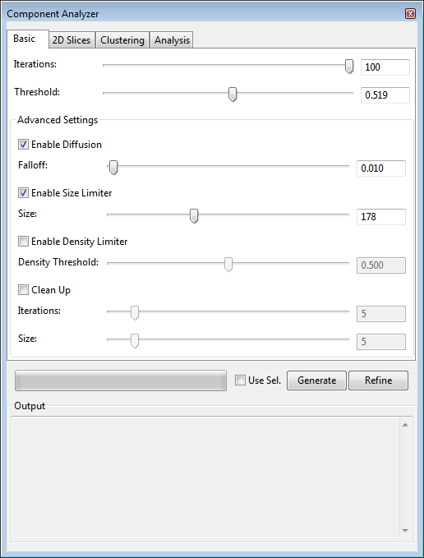

Figure 9‑1. The basic settings in the “Components” dialog.

3a. Depending on the data, you can choose to generate components with either basic or advanced settings. The first tab of the Component Analyzer window contains basic settings.

3b. Set an iteration number and threshold for component generation. Click “Generate” to perform the calculations. If you think the result has unmerged components, you can click “Refine” to continue component generation based on existing result.

3c. You can enable diffusion in the basic settings, which makes a falloff value available for adjustment. Diffusion allows a transition from the threshold to lower intensity values.

3b. You can set a size limiter for component merging. After each iteration, the algorithm checks the size (voxel count) of each component. Components of sizes greater than the limiter are identified. They are not allowed to be merged into other greater size components. Only components with sizes less than the limiter can be merged into other greater components. This is useful when you are dealing with cells sometimes connected with each other. The segmentation stops when the predefined size is reached.

3c. You can set a density limiter for component merging. The density of a voxel is defined by the ratio between the summed intensity within a neighborhood at the voxel and the maximum intensity of the neighborhood. Low intensity means structure boundaries. This measure avoids the cases when two structures are connected by a small amount of high intensity voxels, which cannot be detected by intensity threshold only. The algorithm checks the density of each voxel, and stops component merging if the density values are lower than the limiter.

3d. Since using the density limiter along usually results single-voxel components surrounding structures, the cleanup settings can be enabled to let large components “absorb” neighboring small components.

4. You can use the advanced settings to fine tune the component generation process. For details on setting the advanced component generation, see Chapter 16 of the User’s Guide.

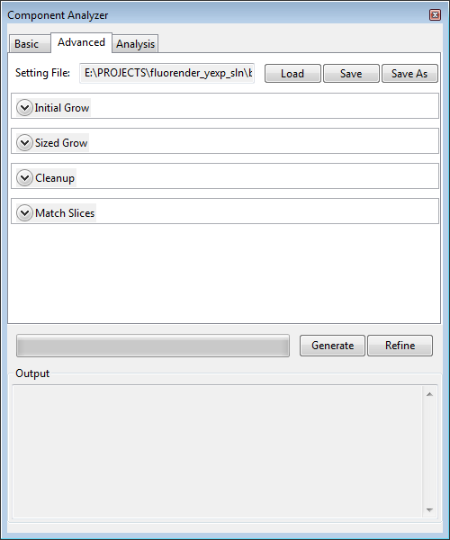

Figure 9‑2. The advanced settings in the “Components” dialog.

5. To visualize individual components in different highlighted colors, you need to turn on “4D script” function. To turn on “4D script”, go to the “Settings” dialog, on the first panel “Project”, check “Enable execution of a script on 4D data during playback”. Although you do not need an actual 4D script file to be executed, nor a time sequence, you need this option because component labeling is closely related to tracking features in 4D. To best distinguish highlighted components and unselected data, it is recommended to assign a white color to the volume channel.

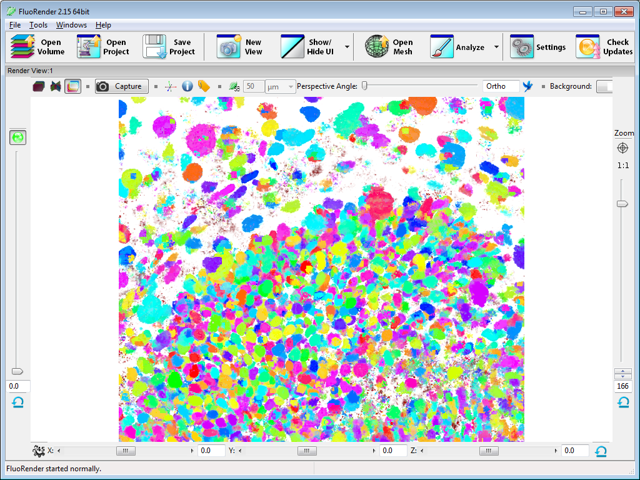

Figure 9‑3. Components visualized in different colors.

# Fully Automatic Tracking of Components

|  |  |
| --- | --- |
|  | **On YouTube:**  [**https://youtu.be/IyYPYHyWoic?t=11m**](https://youtu.be/IyYPYHyWoic?t=11m)  **Start at 11:00, Part III Automatic Tracking**  **Or search:**  **FluoRender Tutorials 4D Tracking and Analysis** |

FluoRender can generate a track map for a labeled 4D sequence. Then, one or multiple components can be selected to show their tracked movements through time.

1. Prepare data. You need a 4D sequence containing at least 2 time points. If you use our included labeling application (Windows only), make sure that you are tracking relatively small structures, such as nuclei. Within each time point, there need to be sufficient space between two separate structures in order for the labeling application to distinguish them. Also, a moving structure should overlap with itself from the previous time point.

2. Load a 4D sequence into FluoRender. You can download a sample 4D data set from FluoRender’s download website. The sample data set contains 11 volumes that are named from B4D\_T000.tif to B4D\_T010.tif. Make sure that you set the correct time sequence identifier so that the 4D sequence is loaded and played correctly in FluoRender.

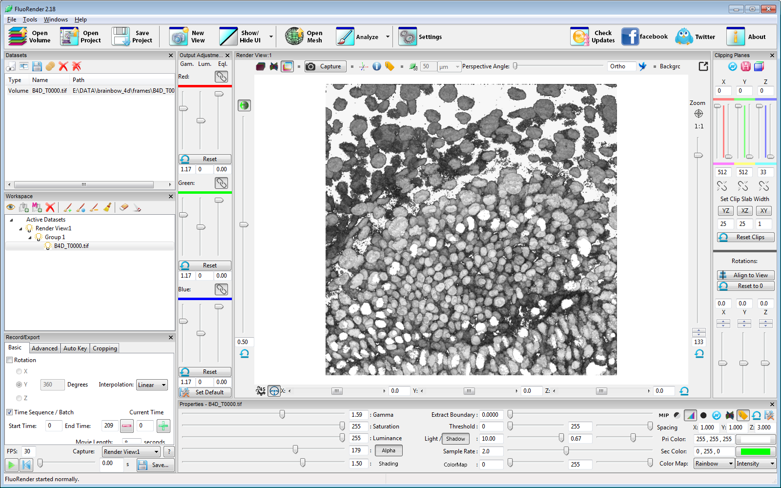

Figure 10‑1. Loading the sample 4D sequence into FluoRender

3. Enable 4D script for external application execution. In the “Record/Export” panel, choose the “4D Script” panel. Enable 4D script and then select “script\_4d\_generate\_comp” from the built-in script file list. You can also find this sample script in the *Scripts* directory of FluoRender’s installation folder.

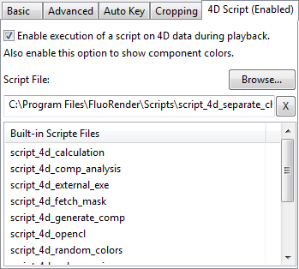

Figure 10‑2. Enable a 4D script for generating components

This script applies the settings in the Component window to each time point of the sequence and then save the resulting label masks:

|  |
| --- |
| [tasks]  tasknum=2  [tasks/task0]  type=generate\_comp  gentype=0  mode=0  [tasks/task1]  type=save\_mask  toffset=1 |

You need to first run component generation and find the best segmentation parameters for the data set. See Tutorial 9 for the details of running component generation.

4. Play back the 4D sequence from the beginning to the end. For each time point, FluoRender generates components for each time point and saves a label file (\*.lbl) in the same directory as the original sequence. The labeling application should assign a unique ID to each component in the volume for each time point. Wait until the entire sequence finishes playing.



Figure 10‑3. FluoRender shows the components generated for each time point when you play back and execute the script.

5. Generate a track map. Open the Components & Tracking dialog window. Make sure the 4D sequence is the current selection and highlighted in the Workspace panel. Go to the first tab of the Components & Tracking window, Track Map. Click Generate on the tab page to generate a track map. The progress of calculation is shown in the Output box of the Component & Tracking window. If the track map is correctly generated, the text box next to “Track map:” reads “Track map generated but not saved”. You can save the track map for later use.

The track map generation can be a progressive process, which is broken into a series of iterations. Each iteration goes through all time point, links and unlinks components between two adjacent time points. More iterations usually generate a more accurate tracking result than a single iteration. You can control how many iterations by directly setting the number. You can load a track map generated earlier, and then choose “Refine All” to add more iterations.

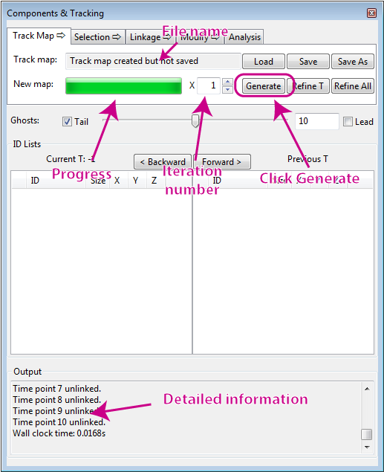

Figure 10‑4. Generating a track map.

6. Visualize tracking results. You need to first enable another 4D script to show tracking results. Select “script\_4d\_selection\_tracking” from the “4D Script” tab of the “Record/Export” panel. You can also load a script file like this:

|  |
| --- |
| [tasks]  tasknum=1  [tasks/task0]  type=selection\_tracking |

You can find the same file with the name script\_4d\_selection\_tracking.txt in the *Scripts* directory of FluoRender installation.

Use the paint brush tool to select one or any number of structures. Notice that labeled components are visualized with different colors. It is convenient to set the primary color of the volume to white, so that selections can be easily distinguished. When you step through time, the tracking results are updated automatically. To step forward or backward one time point, use the buttons in the “Components & Tracking” window. Alternatively, you can use keyboard shortcuts D and A.

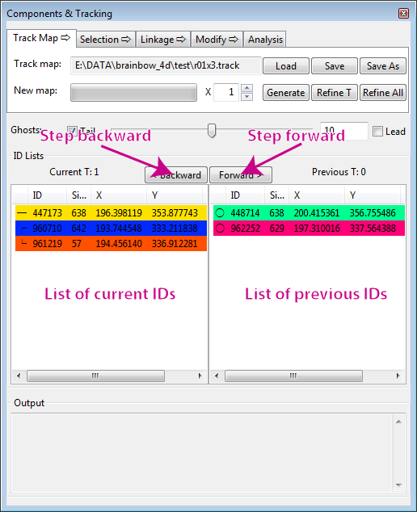

Figure 10‑5. Stepping through time.

7. If you know the integer ID of a specific component, you can use the component selection tools to select it. The component selection tools are on the second tab of the “Components & Tracking” window, Selection. Type the integer ID into the text box next to “Selection tools:”, and then click either Replace to isolate the component, or Append to add the component to existing selections. Click Clear to clear all selections. You can copy and paste the IDs from the ID lists by right clicking and choose Copy from the context menu.

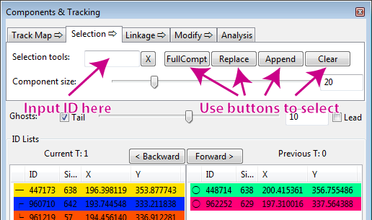

Figure 10‑6. Selecting components by ID.

8. You can choose to visualize either the leads or tails or both of a trajectory. Check the corresponding options in the Ghost settings. Leads are trajectories ahead of a tracked component in time; tails are those behind in time. You can also input a number for the length of leads and tails.



**Tails**

**Leads**

Figure 10‑7. Ghosts of a tracked cell.

|  |  |
| --- | --- |
|  | Since version 2.17, a new format (\*.track) for the tracking results is adopted. The old format (link map, \*.fll) becomes deprecated and unsupported in the new versions. The two formats are also incompatible with each other. Use tracking result files only with the version of FluoRender that generated them. |

9. Disable 4D script in the settings if you do not want to execute the script for the next operations.

# Manually Fixing Automatic Tracking Issues

|  |  |
| --- | --- |
|  | **On YouTube:**  [**https://youtu.be/IyYPYHyWoic?t=13m48s**](https://youtu.be/IyYPYHyWoic?t=13m48s)  **Start at 13:48, Part IV Fixing Tracking Issues**  **Or search:**  **FluoRender Tutorials 4D Tracking and Analysis** |

Automatically generated track maps may contain mistakenly tracked trajectories. Use the Linkage and Modify tab pages of the “Components & Tracking” window to manually fix the issues. You need to first read and practice Tutorial 10 in order to follow the operations in this tutorial.

1. Load a time sequence and perform automatic tracking. Alternatively, you can load a previously generated track map. Make sure that the selection tracking 4D script is loaded and enabled. More details are discussed in Tutorial 10.

2. To detect issues in tracking, you first select one or several components from the render view, and then step through time to see if they are tracked correctly. Alternatively, you can first generate a new time sequence with consistent IDs through time and play back the newly generated sequence. Issues in tracking are presented as abrupt changes of colors.

3. To generate a new time sequence with consistent IDs, go to the last tab of the “Components & Tracking” window, and then click “UniIDs”. In the directory browser, choose a directory other than that containing the current sequence, and click “Select Folder”. The tool will start generating a new sequence.

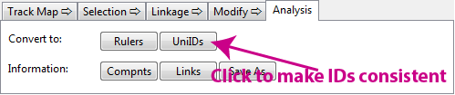

Figure 11‑1. The UniIDs tool generates a new sequence with consistent IDs through time.

You can select several components to see if they are tracked correctly. To visualize all components, enable a different 4D script, script\_4d\_fetch\_mask. Then, you can select the entire data set.

4. Once a tracking issue is detected, you can use the tools in the Linkage tab of the “Components and Tracking” window to link and unlink components from two time points.

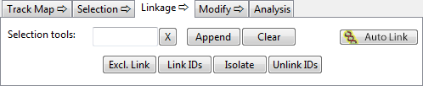

Figure 11‑2. The Linkage tab of the Components and Tracking window.

5. There are four operations in the Linkage tab: Exclusive link, Link IDs, Isolate, and Unlink IDs. These operations are applied on the IDs listed in the current and previous ID lists.

6. The exclusive link operation makes sure only the IDs listed in the current and previous ID lists are linked, any previously linked IDs but nor present in the ID lists are unlinked.

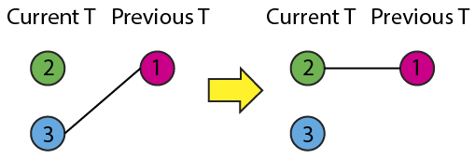

Figure 11‑3. Exclusive Link.

In Figure 11‑3, we track from previous T to current T, and find component with ID 1 is linked to another component with ID 3, which is wrong. ID 1 should be linked to a third component with ID 2. We select component with ID 2 from the render view using the paint brush. Then, click ID 3 in the current ID list and press the Del key on keyboard. Now, there should be ID 1 in the previous ID list and ID 2 in the current ID list. Click the “Exclusive Link” button in the Linkage tab. It will unlink ID 1 and ID 3, and then link ID 1 and ID 2. Use exclusive link to fix mistakenly tracked components.

|  |  |
| --- | --- |
|  | If you don’t want to delete an existing selection, such as ID 3 in the example, you can click select items in the ID lists. The operations will be applied to only the selections. In this example, you can click and select ID 2 in the current ID list and then click “Exclusive Link” to achieve the same result. |

7. The Link IDs operation adds links to existing links.

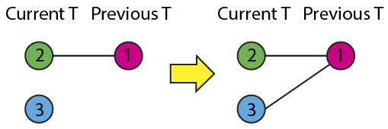

Figure 11‑4. Link IDs.

In Figure 11‑4, we track from previous T to current T, and find component with ID 1 is linked to another component with ID 2. Additionally, we find a third component with ID 3 should be linked with ID 1 as well. To add a link between ID 1 and 3, we select the component with ID 3 from the render view with the paint brush, and then click the “Append” button of the selection tools. It adds ID 3 to the current ID list. Then, we click the button “Link IDs”. It adds links to every ID in the current and previous ID lists. Now, ID 1 is linked to both ID 2 and 3. Use link IDs to add a daughter cell if it is not tracked.

8. The Isolate operation breaks any existing links to an ID.

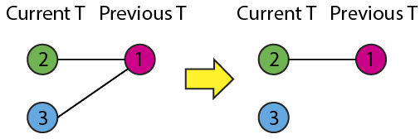

Figure 11‑5. Isolate.

In Figure 11‑5, we track from previous T to current T and find the component with ID 1 is linked to both ID 2 and 3. Only the link to ID 2 is correct. We can either first delete ID 2 from the current ID list, or click and select ID 3 from the current ID list. Then, click the button “Isolate”. It breaks all links to ID 3, which is isolated without any links. Use the isolate operation to first simplify a complex linking situation, and then reestablish some links.

9. The Unlink IDs operation removes links between IDs.

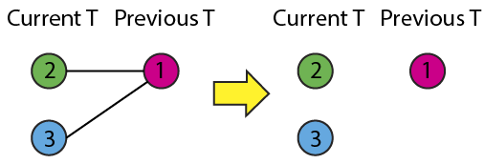

Figure 11‑6. Unlink IDs.

In Figure 11‑6, we have ID 2 and 3 listed in the current ID list, and ID 1 in the previous ID list, which is linked to both 2 and 3. To break the links, click the button “Unlink IDs”. The links will then be removed.

10. There are situations that components are mistakenly segmented and IDs need to be modified. Use the tools in the Modify tab of the Components and Tracking window to modify IDs. Five operations are available: Assign ID, Add ID, Replace ID, Combine, and Divide.

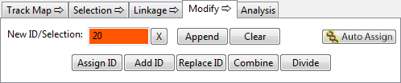

Figure 11‑7. The Modify tab of the Components and Tracking window.

11. The Assign ID operation assigns a new ID to the currently paint-brush-selected part in the render view. It first looks the value in the New ID input box. If the input box is empty, it will automatically generate a new ID. It also makes sure the newly assigned ID doesn’t conflict with the existing IDs. Therefore, the ID you enter in the New ID may not be the one finally assigned. However, it will match the color as shown in the New ID input box.

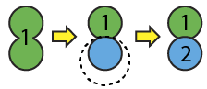

Figure 11‑8. Assign ID.

In Figure 11‑8, two structures are segmented as one component. We use the paint brush to select one structure, and then click “Assign ID”. A new ID is assigned to the selected structure, which becomes an independently trackable component.

12. The Add ID operation works similarly to Assign ID, except that it works only on data without ID already assigned. This is useful when you want to manually segment structures from scratch.

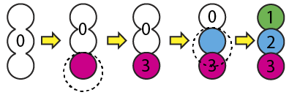

Figure 11‑9. Add ID.

In Figure 11‑9, three structures are fused together. We want to separate them into three components. First select one structure using the paint brush tool. Click Add ID to assign an ID to the selection (ID 3). Next, without clearing the selection, use the paint brush again to select the structure in the middle. It doesn’t matter the paint brush also covers part of the first component with ID 3. Click Add ID to assign another ID to the selection (ID 2). Repeat it to assign a third ID to the last structure as well.

13. The replace ID operation replaces the selection with a new ID entered in the New ID input box. You usually don’t want to simply replace IDs unless you want to change the color of a component for better distinction.

14. The Combine operation combines the selected IDs into a single ID.

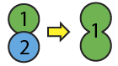

Figure 11‑10. Combine IDs.

In Figure 11‑10, we select two components with ID 1 and 2. Then, click the Combine button to merge the two components into a single component with one ID.

15. The Divide operation divide two components into independently trackable components. Some components may be considered a group after automatic tracking. Components in the same group are tracked as one object. Components in one group are indicated by symbols ┌, │, and └ in the ID lists. If components in one group are actually different structures, use the divide operation to separate them.

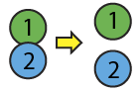

Figure 11‑11. Divide an ID group.

In Figure 11‑11, two components are grouped together. Select both components and add them to the ID list. Click the Divide button to separate them into independently trackable components.

16. Save the track map after you have finished fixing the issues. It is possible to refine the track map fixed through manual work. The automatic program will honor the changes made by user and pick up issues in the neighboring regions.

# Fully Manual Tracking

|  |  |
| --- | --- |
|  | **On YouTube:**  [**https://youtu.be/IyYPYHyWoic**](https://youtu.be/IyYPYHyWoic)  **Or search:**  **FluoRender Tutorials 4D Tracking and Analysis** |

Tools used for fixing automatic tracking issues are capable of fully manual tracking from scratch. Use ID assignment tools to assign IDs through time. Then, use ID linking tools to link them. The Linkage and Modify tabs in the Components and Tracking window provides to automatic modes to simplify the manual tracking process, as long as one component is tracked at a time. Following the steps to track one component.

1. Load a 4D sequence into FluoRender. You can download a sample 4D data set from FluoRender’s download website. The sample data set contains 11 volumes that are named from B4D\_T000.tif to B4D\_T010.tif. Make sure that you set the correct time sequence identifier so that the 4D sequence is loaded and played correctly in FluoRender.



Figure 12‑1. Loading the sample 4D sequence into FluoRender

2. Enable 4D script in the “4D Script” tab of the “Record/Export” panel. Select “script\_4d\_selection\_tracking” from the list.



Figure 12‑2. Enable a 4D script that allows tracking selected components.

You can find the same file with the name script\_4d\_selection\_tracking.txt in the *Scripts* directory of FluoRender installation.

|  |
| --- |
| [tasks]  tasknum=1  [tasks/task0]  type=selection\_tracking |

3. Enable Auto Assign and Auto Link in the Components and Tracking window.

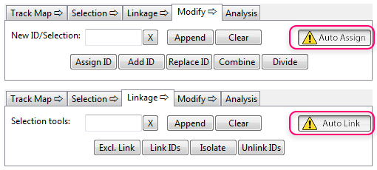

Figure 12‑3. Enable Auto Assign and Auto Link.

When Auto Assign is enabled, a new ID is assigned each time a selection is made using the paint brush tool. Notice that no ID will be assigned to selections that already have IDs. You don’t need to worry about overwriting existing IDs. When Auto Link is enabled, the listed IDs in the current and previous time points are linked after each paint brush selection. Make sure that you are tracking only one component at a time. Otherwise all components are linked to each other.

4. Start tracking one component from the first time point. Paint and select one component from the render view. Observe that a new ID is assigned to the selection and the ID is added to the current ID list.

5. You can make modifications to the selection. ID assignment will be updated automatically. To include more structures to the selection, use the diffusion brush. The added selection will be assigned with the same ID. To erase part of the selection, use the unselect brush. The erased parts will have ID reset to 0.

6. Use the keyboard shortcut D to proceed to the next time point. Make sure the mouse cursor is in the render view region in order to use this shortcut. The ID in the current ID list is moved to the previous ID list. Observe where the select component is located in the next time point.

7. Use the paint brush to select the component in the next time point. Observe that an ID is assigned to the selection, which is added to the current ID list. The two IDs in the current and previous ID lists are also linked automatically. Depending on the ghost settings, the linking may show as a line segment, with its two ends at the centers of the components from two time points.

8. Repeat until the component is tracked through all time points.

9. Go to the first time point and start tracking a second component using the same procedure. A different ID will be automatically assigned to the second component.

10. If you leave the New ID input box empty, a new ID is generated each time a new component starts being tracked. The same ID will be assigned to the same component through time. You can also designate an ID for each component by enter the ID value into the New ID input box.

11. Disable Auto Assign and Auto Link when manual tracking is finished for all components.

12. Save the track map generated from manual tracking.

13. It is possible to mix automatic and manual tracking by passing the track map between different workflows.

# Image Processing with OpenCL Kernels

FluoRender allows you to take advantage of modern graphics hardware for image processing with parallel computing. OpenCL is the interface language used in FluoRender to perform computations on a selected volume channel. A piece of OpenCL code for a specific image processing function is called a kernel.

1. Prepare data. An OpenCL kernel can be applied to a volume channel loaded and visualized in FluoRender. Although FluoRender automatically applies a kernel to each data brick when data streaming is enabled, it is recommended that data streaming is disabled for best performance. Changes to data streaming mode have to be made before data loading. To turn off data streaming, go to the “Performance” panel in the “Settings” dialog, and uncheck “Enable streaming for large datasets”.

2. Kernels are managed in the “OpenCl kernel editor” window. To open “OpenCL kernel editor” window, click the downward arrowhead to the right of the “Analyze” button in the main toolbar. In the drop-down menu, choose “OpenCL kernel editor”.



Figure 13‑1. OpenCL kernel editor.

3. Names of kernel files (\*.cl) are listed in the list on the left. These files are in the \CL\_code folder of FluoRender’s installation folder. Click the name of a kernel file, and its code is loaded into the code editor on the right.

4. You can browse and load a kernel file saved elsewhere than the default folder. To browse and load a kernel file, click “Browse”. In the file browser dialog, choose a valid OpenCL kernel file. Its code is loaded to the code editor on the right of the window.

5. You can modify a loaded kernel code, or write your own code from scratch. Code can be edited in the code editor on the right of the window. A reference manual of OpenCL 1.2 can be found here: <https://www.khronos.org/registry/cl/sdk/1.2/docs/man/xhtml/>.

6. To execute a kernel, click “Run”. If the kernel fails to execute, error messages are output to the “Output” box at the bottom.

7. A new channel is created as the result of the execution of a kernel. If you repeatedly execute a kernel on a newly generated channel, no more new channel will be created again.

# Index

A

Alpha 11

C

Channels 7, 24, 31, 36

Clipping plane 13, 39

Colocalized 9

Component analysis 40

Composite mode 9

D

Depth calculation 32

Depth mode 8

E

Equalization 13

F

FPS 23

G

Gamma 10, 13

I

Install 5

Interpolation 12

L

Layered mode 8

M

Measurement 31

MIP 12

N

Noise 10

O

OpenCL 58

P

Paint brush 33, 36, 40

S

Sample rate 12

Select 10, 33, 36

Sequence 15, 20

Settings 7, 12, 17, 23, 24, 25, 33, 37

Shading 12

Shadow 12, 25

Streaming 7, 36, 40, 58

T

Threshold 11, 37, 38

Tracking 34, 44